Project Report, Phase IV: Software Testing

**Introduction to Testing:**

Software testing is the process of evaluating software to identify defects or bugs. It's crucial in software development to ensure reliability and correctness of the software.

**Purpose of Testing:**

The aim of testing is to identify defects early in the development process and verify that software components perform as intended.

**Focus on Testing a Single Component:**

We'll focus on the (MoveValidator) class in our chess game software. This class is critical as it validates the legality of moves, ensuring the rules of chess are adhered to. Its complexity and impact on the system make it a prime candidate for thorough testing.

**Preparing Test Cases:**

We'll prepare test cases covering various scenarios:

- Normal inputs: Standard moves for each piece.

- Edge cases: Special moves like castling or en passant.

- Invalid inputs: Moves that break the rules of chess.

**Choosing Testing Frameworks:**

Our chess game is written in python so we will use IDLE python and pygame.

**Writing Test Code:**

Here's an example of how to write test code for the MoveValidator class:

java

@Test

public void testPawnMove() {

Board board = new Board();

MoveValidator validator = new MoveValidator(board);

// Test pawn's first move (can move 2 squares forward)

assertTrue(validator.isMoveValid(new Move(6, 0, 4, 0)));

// Test pawn's subsequent move (can only move 1 square forward)

board.movePiece(new Move(6, 0, 4, 0));

assertTrue(validator.isMoveValid(new Move(4, 0, 3, 0)));

// Test invalid move (pawn moving backwards)

assertFalse(validator.isMoveValid(new Move(3, 0, 4, 0)));

}

**System Testing:**

Testing plays a very important role in games. We have tested our game at different level of its development process. Generally, we have used black box testing to test our game. In this, we have tested small pieces of code before submit it for the integration with the rest of the game. Below diagram shows the basic cycle of game testing.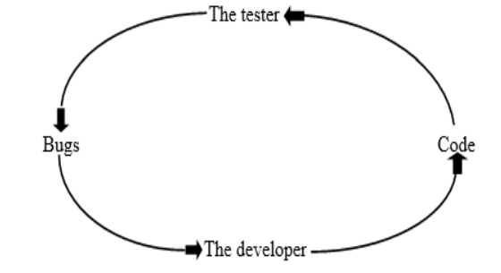

This cycle is performed in the following six steps in order:

**Plan and design the test**: In this, we make test plan document with every new prototype of the game and revisit the code and update if any change is there in the specification. We insure that no new issues were introduced.

**Prepare the test**: In this, we have updated our code, tests, document and align it with one another.

**Perform the test**: In this, we have run the test suit again. If any defect is found, we test around the defect to make sure that the bug is certain.

**Report the results**: In this, we have reported the complete details about the bugs.

**Repair the bugs:** In this, we provide the direct testing to track the bug and repair it.

**Return to step 1 and retest**: In this, we return to the step 1 and retest the other prototype of the game in the same manner.

Game testing is performed in a structured manner. It is irrespective of the size of the game and time required for producing game.

**Alpha Testing:** The main testing begins in this step. In this we play the game from start to finish along some path and revised it. All modules of the game are tested at least for once.

**Beta Testing:** Beta testing begins right after the end of alpha test. In beta testing, we focus mostly on perfecting the game. Beta test identifies and fixes the remaining bugs. It is usually performed by the end user not by the developer. The end user play the game along all possible path, the entire user interface and game logic is final, all controllers work and final artwork & audio is implemented.

Worked by:

Adrian Ahmati

Albjori Dollani

Arbi Maloku

Gledian Alimema

Hysen Allushi

Orgest Shira